AI Grocery Application

Team no. 7 Members:   
 1. Arashdeep Singh

2. Jeevanjot Khehra

3. Vedant Sharma

4. Mustafa Toygar Baykal

Data Flow Diagram (DFD)

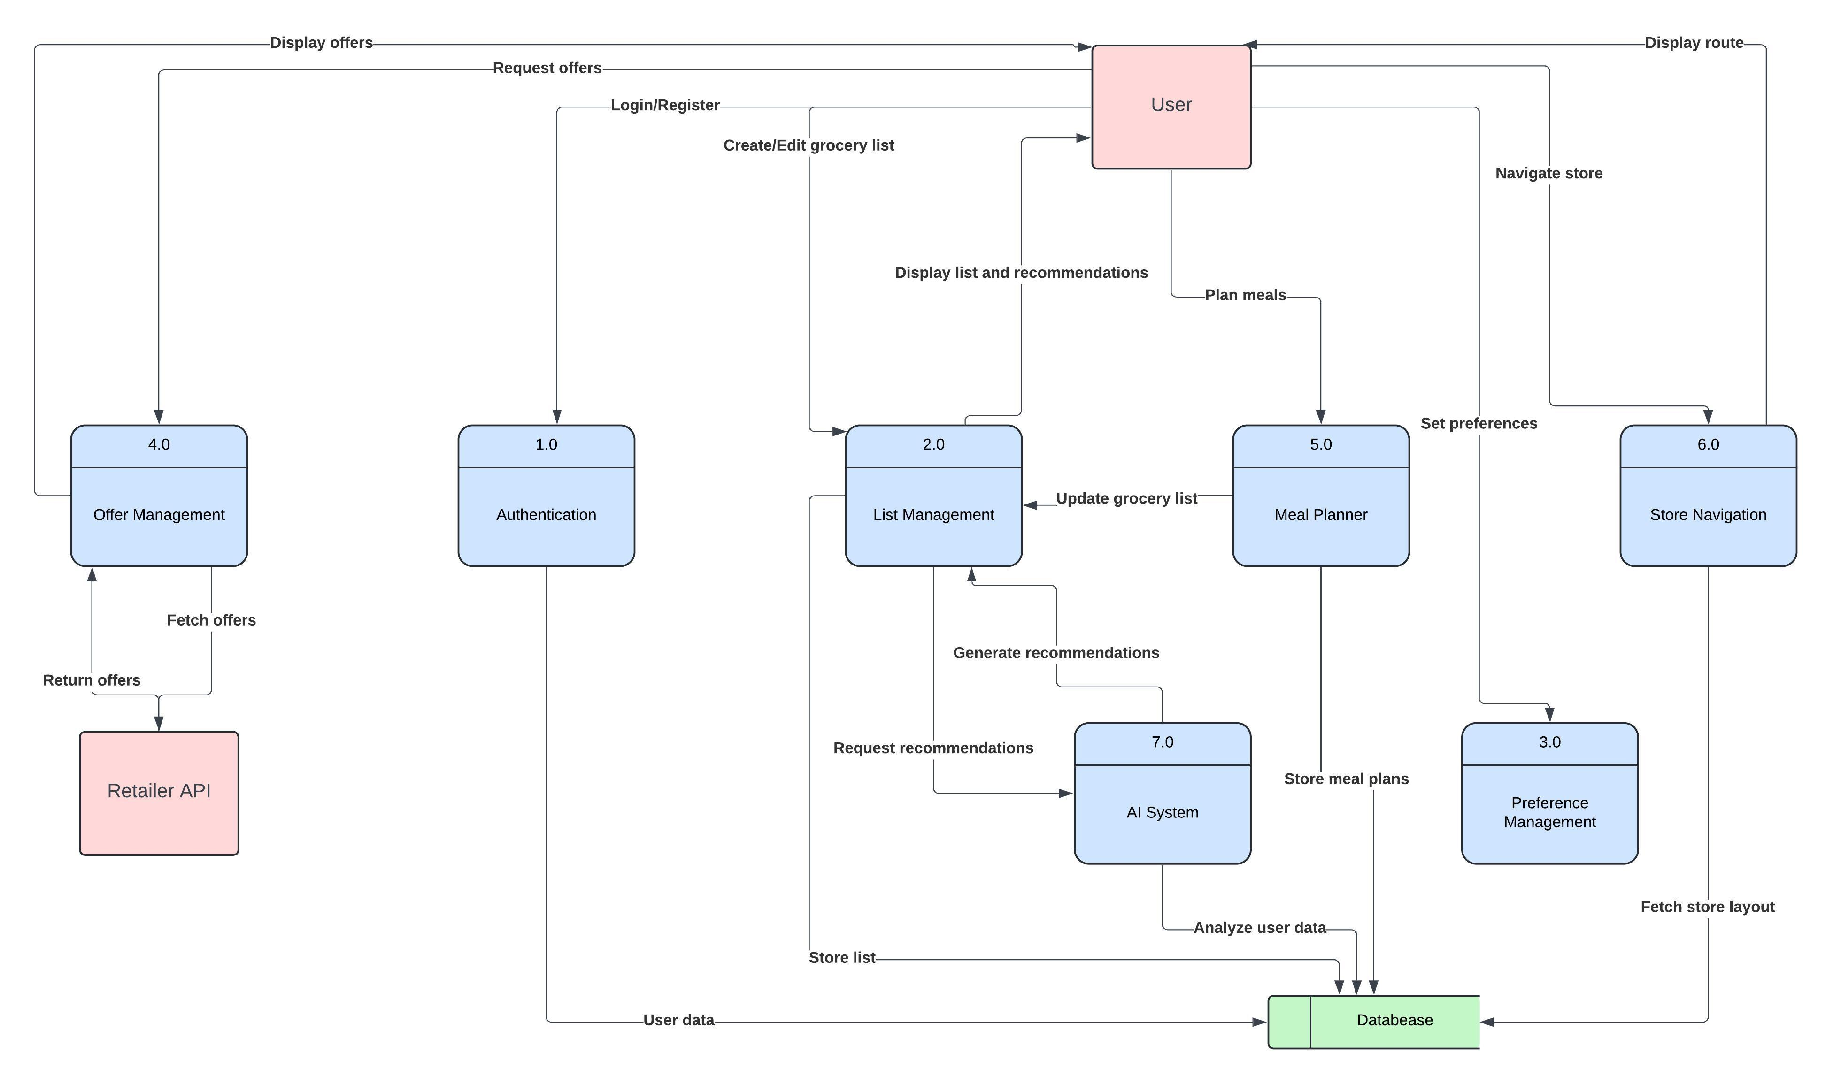

Activity Diagrams

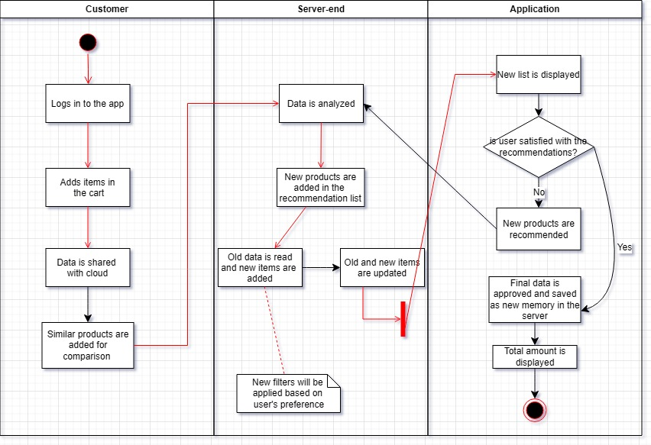

User stories categorized by user roles

**1. Regular User**

1. **As a user**, I want to register an account using my email or social media accounts so that I can quickly sign up and start using the app, helping me save time.
2. **As a user**, I want to update my profile with dietary preferences, so that the app provides grocery recommendations that suit my needs.
3. **As a user**, I want to receive AI-generated grocery lists based on my past purchases, so that I can save time and avoid unnecessary purchases.
4. **As a user**, I want to manually add or remove items from my grocery list so that I have full control over what I purchase.
5. **As a user**, I want to view real-time discounts on items in my grocery list so that I can save money while shopping.
6. **As a user**, I want to navigate through the store using an in-app map so that I can find items quickly and reduce shopping time.
7. **As a user**, I want to share my grocery list with family members so that they can add items or make edits in real time.

**2. Family Account User**

1. **As a family account user**, I want to create and share a grocery list with my family members so that everyone can contribute to the shopping list.
2. **As a family account user**, I want to set permissions for shared lists so that I can control who can edit or just view the list.
3. **As a family account user**, I want to receive notifications when someone updates the shared list so that I stay informed of changes.
4. **As a family account user**, I want to view a budget summary for shared lists so that we can stay within our family budget.

**3. Admin/User with Special Access**

1. **As an admin**, I want to manage user profiles and dietary preferences, so that I can ensure personalized grocery recommendations are accurate.
2. **As an admin**, I want to configure the app to show relevant offers and discounts based on user preferences so that I enhance the user experience.
3. **As an admin**, I want to set up multi-language support for users, so that they can interact with the app in their preferred language.

**4. Retail Partner/Discount Integration Specialist**

1. **As a retail partner**, I want to integrate my store’s discount data with the app so that users can see real-time offers on products.
2. **As a retail partner**, I want to customize discount notifications to target specific user segments so that I can increase engagement with relevant promotions.
3. **As a retail partner**, I want to receive insights on user purchasing behavior so that I can optimize the discounts and offers available in the app.